Plant Disease Detection App Using Deep Learning

By Reyen Lourdes

U18IW23S0146

Introduction
The Plant Disease Detection App is a deep learning–based mobile application developed as part of my final year BCA project. Agriculture is one of the most important sectors, and plant diseases can significantly affect crop yield and quality. Early detection of plant diseases is essential to prevent crop loss and improve productivity.
In traditional methods, farmers depend on experts to identify diseases, which may not always be accessible or timely. This project aims to provide a smart and efficient solution by using Deep Learning techniques to automatically detect plant diseases from leaf images captured using a mobile camera.
The system uses TensorFlow for training the deep learning model and Keras for preprocessing and building the model architecture. The trained model is converted into TensorFlow Lite (TFLite) format, which is then integrated into an Android mobile application. The app allows users (farmers) to capture leaf images and instantly get disease predictions.

Key Objectives:
- To develop a deep learning model for plant disease classification.
- To provide a mobile-based solution for farmers.
- To enable real-time disease detection using a smartphone camera.
- To deploy the trained model in lightweight TFLite format for mobile efficiency.
Module Description
The project is divided into the following modules:

Data Preprocessing Module
This module uses Keras preprocessing techniques to prepare the data:
- Image resizing (e.g., 128 × 128 pixels)
- Normalization of pixel values
Model Training Module
This module uses TensorFlow and Keras to train a Convolutional Neural Network (CNN) model. The model learns features such as color, texture, and patterns from leaf images.
Algorithms/Techniques used:
- Convolutional Neural Network (CNN)
- Activation functions (ReLU, Softmax)

Model Conversion Module
After training, the model is converted into TensorFlow Lite (TFLite) format. This reduces model size and allows efficient execution on mobile devices.
Mobile Application Module
The Android mobile app is developed to provide a user interface. Features include:
- Capture image using camera
- Upload image from gallery
- Display prediction results

Prediction & Result Module
This module takes the input image, processes it, and uses the trained model to predict:
- Disease name
- Confidence score
The result is displayed instantly on the mobile screen.
Hardware and Software Requirements

Hardware Requirements (Minimum):
- Processor: Intel Core i5 / AMD Ryzen 5
- RAM: 8 GB
- Storage: 1 GB free space
- Android Smartphone (for testing app)
- Internet connection (for setup and dataset download)

Software Requirements:

Operating System:
- Windows 10/11 or Linux (Ubuntu)

Programming Language:
- Python 3.XX or above
- Java / Kotlin (for Android app)

Libraries & Frameworks:
- TensorFlow (model training)
- Keras (data preprocessing & model building)

Mobile Development:
- Android Studio
- TensorFlow Lite (TFLite)

Development Tools:
- Jupyter Notebook
- Android Studio

Data Flow Diagram and Table

Data Flow Description
The system follows this workflow:
- Image Input
User captures leaf image using mobile camera
- Preprocessing
Image is resized and normalized
- Model Processing
TFLite model analyzes the image
- Prediction
Disease is identified
- Output Display
Result shown in mobile app
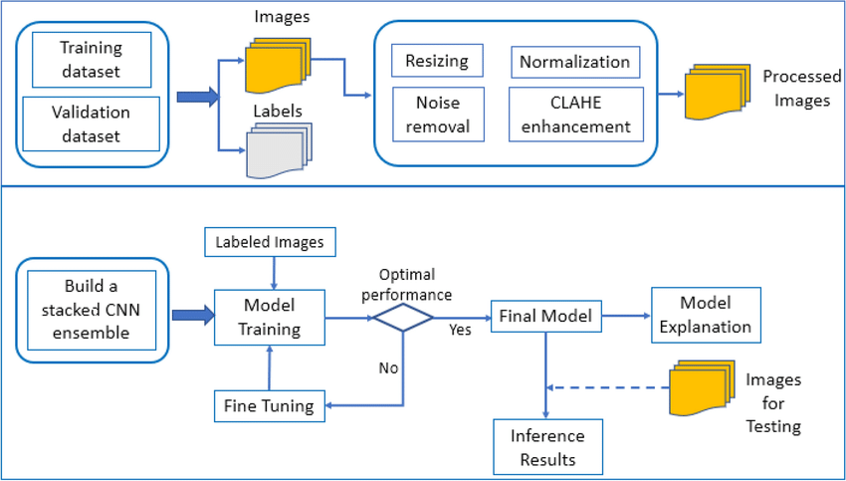

Sample Dataset Table
Image ID | Plant Type | Condition | Disease Name | Label
1 | Tomato | Healthy | None | 0
2 | Tomato | Diseased | Early Blight | 1
3 | Potato | Diseased | Late Blight | 2
4 | Pepper | Healthy | None | 0
5 | Tomato | Diseased | Leaf Mold | 3

